**Database** : test_skill-test-trainer

**Cloud** : cloudinary.com

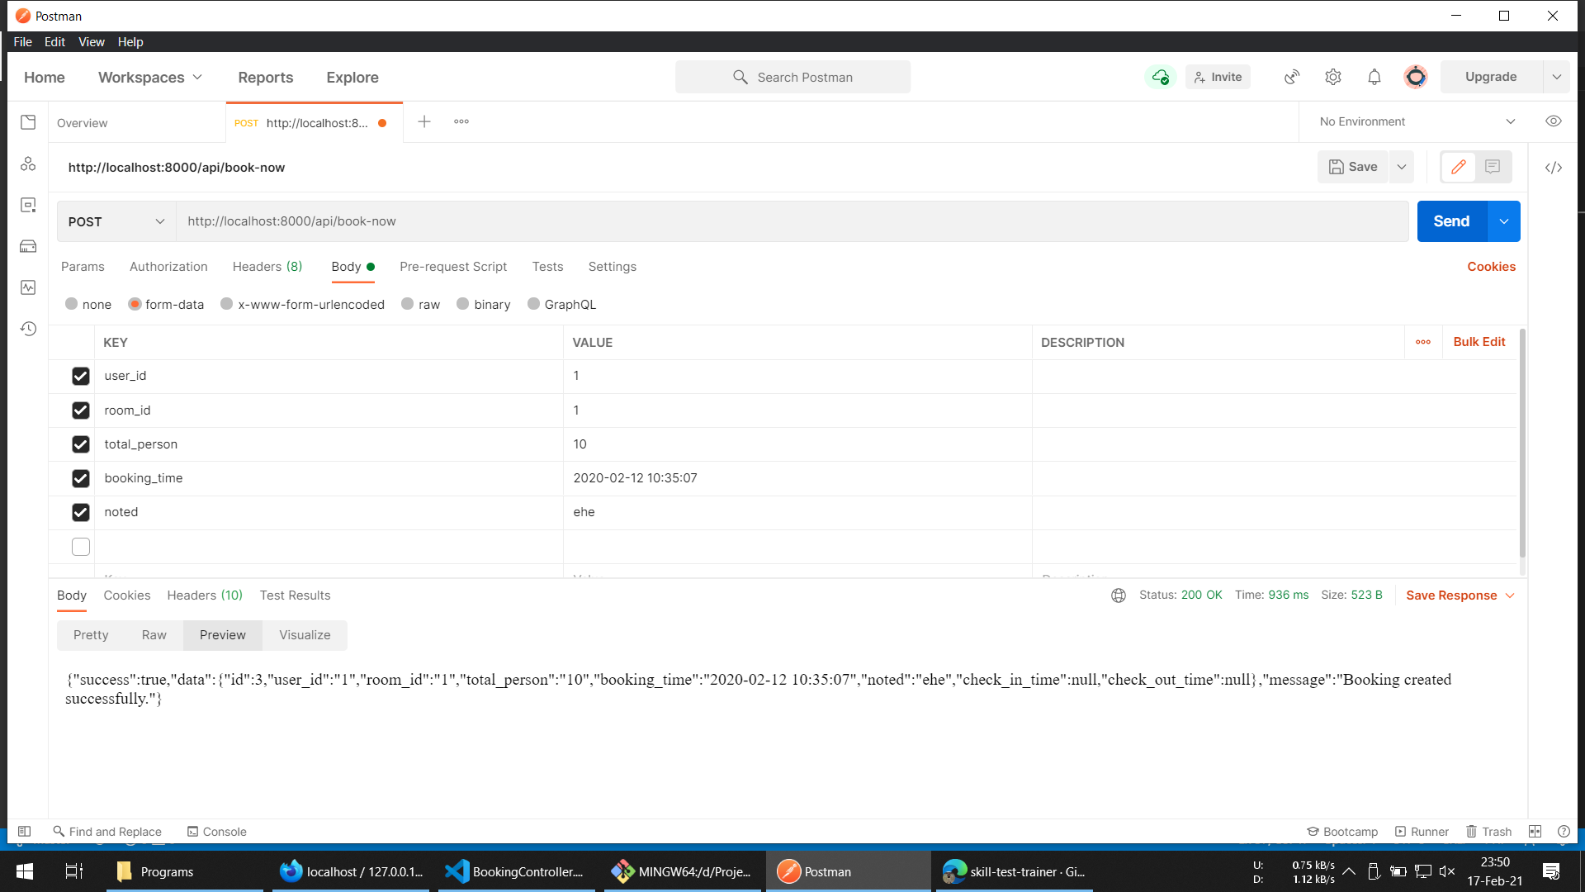

Trial ketika booking sukses

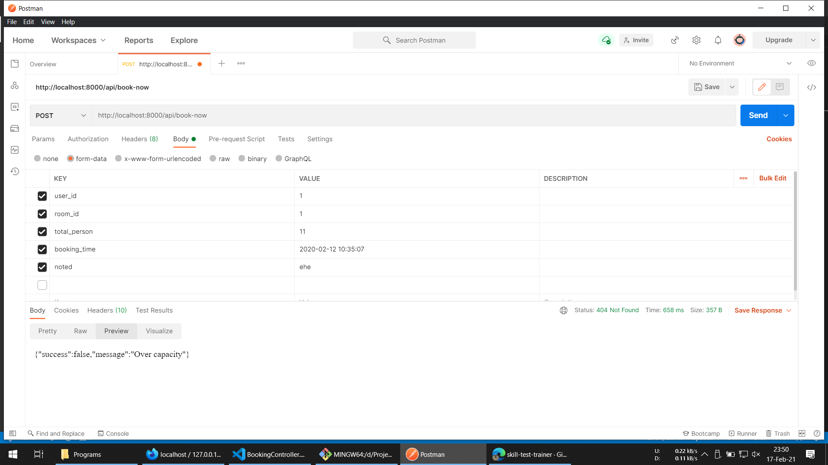

Trial ketika booking gagal (over capacity)

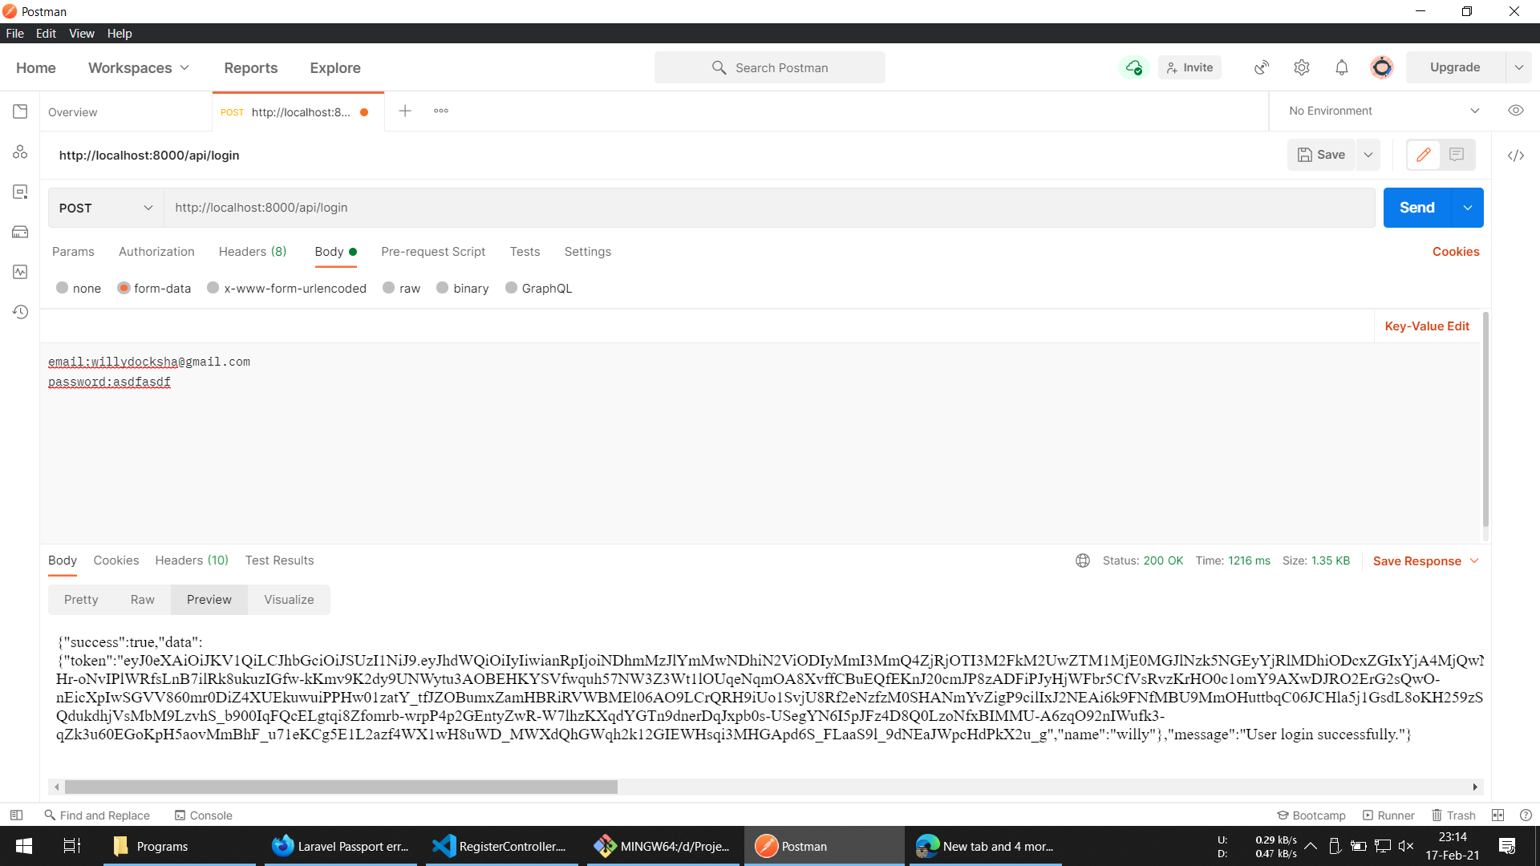

Trial ketika login

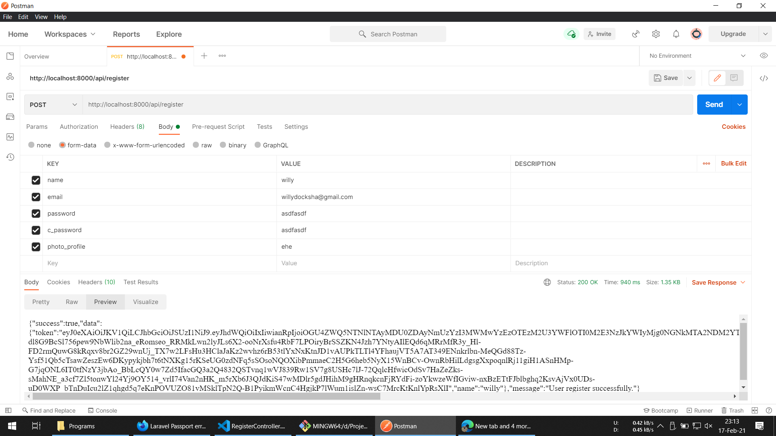

Trial ketika register